SYNOPSIS

ON

“TITLE OF THE PROJECT”

Submitted in

Partial Fulfillment of requirements for the Award of Degree

*of*

Bachelor of Technology

*In*

Computer Science and Engineering

By

**(Project Id: )**

# Student Name (Roll No)

# Student Name (Roll No)

# Student Name (Roll No)

# Student Name (Roll No)

**Student Name (Roll No)**

Under the supervision of

**Supervisor Name**

**(Designation)**



**Pranveer Singh Institute of Technology**.

 Kanpur - Agra - Delhi National Highway - 19

Bhauti -Kanpur - 209305.

(Affiliated to Dr. A.P.J. Abdul Kalam Technical University)

1. Introduction

The introduction part will include the brief introduction about the project to be developed, field of project (if specialized one), any special technical terms about the project (should not exceed 1 page).

2. Project Objective

Project objectives are **what you plan to achieve by the end of your project**. Objectives should be clearly specified. What the project ends up to and in what way it is going to help the end user to be mentioned.

This should give a clear picture of the project. Objectives should

be clearly specified. What the project ends up to and in what way

this is going to help the end user has to be mentioned.

1. Feasibility Study:

Feasibility Study analyses whether the proposed business ideas will succeed or fail. It determines the practicality by assessing the opportunities and threats of the proposed plan.

There are different types of studies to check feasibility, such as **technical feasibility, operational feasibility, economic feasibility, schedule feasibility and legal feasibility.**

**(Prepare a Gantt Chart to represent your project schedule.)**

**Start Date: 09-Sep-2024 End Date: 30-Nov-2024.**

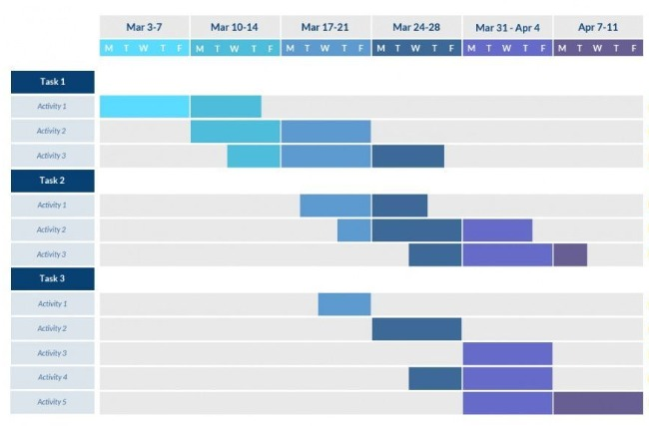

4. Methodology/ Planning of work

Methodology will include the steps to be followed to achieve the objective of the project during the project development. This is to be supported by Architecture Diagram/ DFD/ ER/ Class diagram to explain the flow of information.

5. Tools/Technology Used:

5.1 Minimum Hardware Requirements

Hardware required for the development of the project.

* **CPU:**
* **RAM:**
* **GPU:**
* **HDD:**
* **Others(if any):**

5.2 Minimum Software Requirements

Software required for the development of the project.

* **OS :**
* (Other Tools Used for Development Like Android Studio, Python etc. with specific version.)

6. References: [IEEE format]:

Here specify the description of the study material (Research Papers/other references) referred for the development project.

**Guidelines:**

1) Heading Font Size: 14

2) Content Font Size: 12

3) Font Name: Times New Roman

4) Line Spacing: 1.5”

5) Alignment: Left & Right both Justified

6) Margin: Normal (Top=2.54 cm, Bottom=2.54 cm, Left=2.54 cm, Right=2.54 cm)

7) Page No: At Bottom Right Side

Note: Consider this format for your reference.